Calculating Kinetic Energy
Kinetic Energy=

WE can calculate the kinetic energy a moving object has if we know its mass and speed.
Kinetic energy= 1/2 of the objects Mass X the objects speed squared

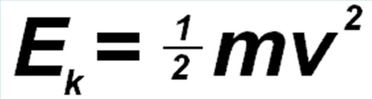
Example
A rock has a mass of 2kg and is falling at a speed of 5 m/s, how much kinetic energy does it have?
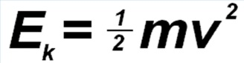
= ( ½ X 2) X 5²
= 1 x 25
= 25 J
Try this one
A toy car has a mass of 4kg and is rolling at a speed of 2 m/s, how much kinetic energy does it have?
= ( ½ x ) X
= j

Comparing 3 Cars
Vehicle | Ford focus | Ford focus | Ford 4WD
Mass(kg) | 1300 | 1300 | 2000
Speed(m/s) | 10 | 20 | 10
Calculation | 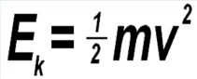  =(1/2 x ) x ² | 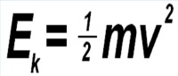 | 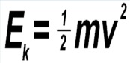
Kinetic energy (j)
Convert the Kinetic energy from Joules(j) to kilojoules(kJ) by dividing by 1000 | /1000 | /1000 | /1000
Final Kj
Draw a bar graph of these results.

Questions
Which vehicle had the most Kinetic energy?

Why was the ford focus able to have a greater kinetic energy than the larger 4wd, even though the 4wd had more Mass?

Why will it take twice as long to stop a car travelling at 65kph than a car travelling at 80kph?

